**Document Objective**: Allow everyone to organize information/data they’ve gathered about the locations they are researching for our project. This document extends upon the data sources document by allowing everyone to pull from each other’s data sources to locate pertinent information which they can place here and brainstorm the potential uses of. This document is meant for continued usage throughout the project, and will hopefully allow project members to better understand each other’s thought processes and methods with respect to researching given locations of interest. The “General Interest Research” section is additionally used for placing generally useful sources of information that are not location-specific. Contributions in this section are indicated with the initials of the contributor in square brackets at the beginning of a given entry (e.g. [BT]: Source on U.S. Lithium Locations: <https://www.google.com/maps/d/u/0/viewer?mid=1kq8TRUSMR97kg-XQ22kdQpE4lUT0Rj49&ll=38.27493251229276%2C-111.50454879999998&z=5>).

### General Interest Research

* [BT] Environmental impacts of current lithium brine extraction: <https://www.nature.com/articles/s43017-022-00387-5>
  + TL;DR: Brine extraction impacts fresh groundwater levels nearby, and is extremely water intensive itself; newer direct lithium extraction (DLE) technology could be much less environmentally costly
  + Background: “Currently, lithium extraction is exclusively from hard-rock ores and [continental brines](https://www.nature.com/articles/s43017-022-00387-5#Glos2), with continental brine resources being more abundant than hard-rock ores. The evaporitic technology currently used to extract lithium from continental brine deposits relies on open air evaporation to concentrate the brine. Large volumes of water, 100–800 m^3 per tonne of lithium carbonate, depending on the deposit, are lost through evaporation, raising concerns about the overall sustainability of the process.”
  + “The analysis suggests that brine pumping could provoke an increase in recharge from underground fresh water towards brine deposits… If this recharge becomes substantial, it will affect the level of nearby fresh water lagoons, rivers and streams and the water table in the surrounding soil. Reports agree that the brine volume that is pumped will directly determine the amount of underground fresh water recharge”
  + “Arguing that brine water is far from being suitable for either human consumption or agricultural use, strong proponents of mining propose that brine should be completely disregarded in water footprint calculations. However, we suggest that brine must be considered, as the brine volume that is pumped will directly determine the amount of fresh water that naturally flows from outside the brine aquifer, is mixed with brine and thus is no longer considered fresh water or can be used as such. The volume of fresh water that flows or moves towards the salar is different during brine pumping or in the absence of mining.”
* [BT] <https://www.jsparling.com/how-to-display-google-earth-maps-on-website/>

### Alex’s Research – Great Salt Lake

* URL: <https://www.sltrib.com/news/environment/2023/11/09/compass-minerals-halt-great-salt/>
* Type(s) of Info Provided/Data Examined: This article by the Salt Lake Tribune highlights the concerns when extracting lithium from the Great Salt Lake by conventional means. The lake is ready at its smallest ever due to the massive drought, and the plans by Compass Minerals would have required a huge amount of not just brine from the lake, but also treated water that would have to be pumped from other places.
* Data Formatting: Article with text
* About Source: The Salt Lake Tribune describes itself as "Utah's independent nonprofit news source covers news, politics, faith, arts and sports for Salt Lake City and Utah." Headquartered in Salt Lake City, "it was founded in 1871 and was known as Mormon Tribune", according to Wikipedia.

**Source (Name)**:

* URL:

<https://lilacsolutions.com/2024/02/with-145m-in-fresh-capital-were-building-the-foundation-of-a-u-s-lithium-supply-chain/>

* Type(s) of Info Provided/Data Examined: This information comes from a startup, Lilac, that wants to harvest the lithium in the Great Salt Lake. They have developed a new, far superior method to extract lithium from brine, that is much more versatile and effective than existing methods, and that also consumes much less water. They talk about how their method is already proven to work, and how it wastes much less lithium and consumes much less of the Great Salt Lake's precious water.
* Data Formatting: Article with text
* About Source: The source is written in first person by the CEO himself. "Lilac Solutions is a lithium extraction technology company based in Oakland, California. Lilac has developed a patented ion exchange technology that facilitates production of lithium from brine resources with high efficiency, minimal cost, and ultra-low environmental footprint. Lilac’s mission is to scale global lithium production to support the electric vehicle industry and energy transition."

**Source (Name)**:

* URL:
* <https://www.wsj.com/science/environment/great-salt-lake-lithium-startup-lilac-d84c9f76>
* <https://humanprogress.org/the-great-salt-lake-is-full-of-lithium-a-startup-wants-to-harvest-it/>
* Type(s) of Info Provided/Data Examined:
* Data Formatting: Article with text
* About Source:

**Source (Name)**:

* URL: <https://www.sltrib.com/news/environment/2024/02/09/mineral-companies-use-7-great-salt/>
* Type(s) of Info Provided/Data Examined:
* Data Formatting: Article with text
* About Source:

**Source (Name)**:

* URL: <https://townlift.com/2024/02/lithium-mining-at-the-great-salt-lake/>
* Type(s) of Info Provided/Data Examined: 85000 acres statistics
* Data Formatting: Article with text
* About Source:

**Source (Name)**:

* URL: <https://www.businessinsider.com/great-salt-lake-lithium-startup-key-to-green-energy-future-2024-2>
* Type(s) of Info Provided/Data Examined:
* Data Formatting: Article with text
* About Source:

**Source (Name)**:

* URL: <https://projectblue.com/blue/news-analysis/769/great-salt-lake-mineral-extraction-bill-passed-by-utah-house-committee>
* Type(s) of Info Provided/Data Examined:
* Data Formatting: Article with text
* About Source:

**Source (Name)**:

* URL: <https://www.sltrib.com/news/environment/2023/09/07/new-lithium-company-wants-billions/>
* Type(s) of Info Provided/Data Examined:
* Data Formatting: Article with text
* About Source:

**Source (Name)**:

* URL: <https://www.utahbusiness.com/what-to-do-about-the-great-salt-lake-drying-up/>
* Type(s) of Info Provided/Data Examined:
* Data Formatting: Article with text
* About Source:

**Source (Name)**:

* URL: <https://extension.usu.edu/irrigation/research/agricultural-water-use-salt-lake-basin>
* Type(s) of Info Provided/Data Examined:
* Data Formatting: Article with text
* About Source:

[**https://pws.byu.edu/great-salt-lake**](https://pws.byu.edu/great-salt-lake)

[**https://climate.usu.edu/GSL.php**](https://climate.usu.edu/GSL.php)

[**https://wildlife.utah.gov/gslep/about/water-levels.html**](https://wildlife.utah.gov/gslep/about/water-levels.html#:~:text=The%20lake%20has%20gone%20through,square%20miles%20of%20surface%20area)

[**https://www.usgs.gov/media/before-after/great-salt-lake-comparison-1986-and-2022**](https://www.usgs.gov/media/before-after/great-salt-lake-comparison-1986-and-2022)

Lithium in energy:

<https://energyx.com/blog/what-is-lithium-used-for-in-renewable-energy/>

<https://pubs.usgs.gov/fs/2014/3035/pdf/fs2014-3035.pdf>

<https://www.energy.gov/eere/geothermal/lithium>

<https://theconversation.com/lithium-is-finite-but-clean-technology-relies-on-such-non-renewable-resources-109630>

<https://www.visualcapitalist.com/sp/tomorrows-lithium-demands/>

Geothermal lithium:

<https://www.energy.gov/eere/geothermal/articles/can-geothermal-energy-solve-lithium-shortfall>

<https://www.energy.ca.gov/publications/2020/selective-recovery-lithium-geothermal-brines>

<https://www.sciencedirect.com/science/article/pii/S2666792423000276>

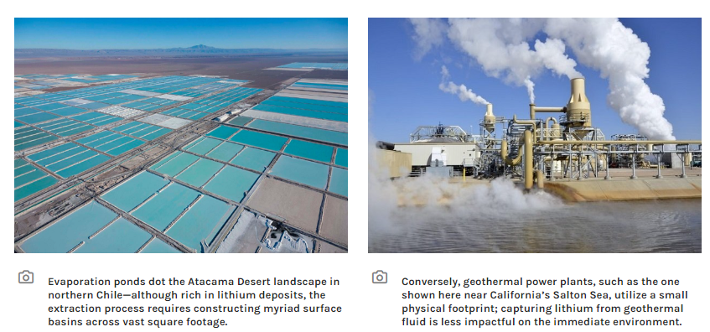

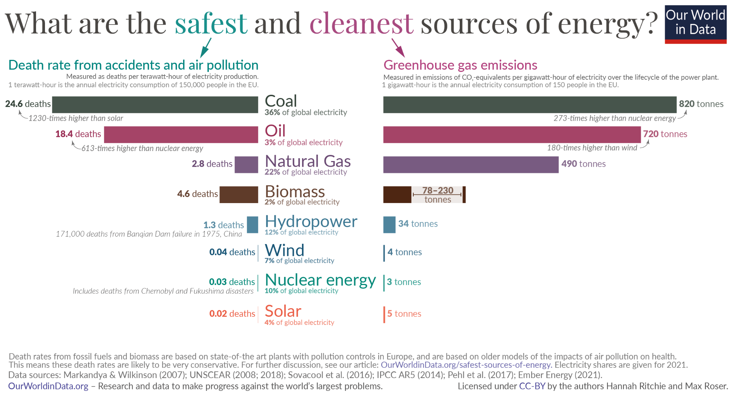

<https://ourworldindata.org/safest-sources-of-energy>

<https://bendingbranches.com/blogs/resources/kayaking-on-great-salt-lake-utah>

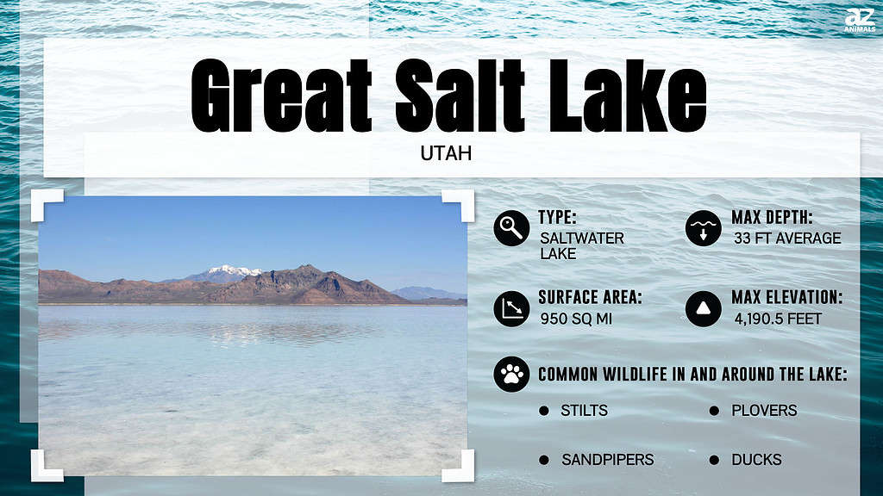

### 

### Ashley’s Research – Salton Sea

### 

### Benjamin’s Research – Silver Peak

* Mine operated by Albemarle
* <https://www.albemarle.com/locations-category/north-america> (About the Silver Peak Operation; note also company’s extraction expansion plans for Arkansas)
* <https://www.albemarle.com/about-us> (About Albemarle, a multinational international lithium extraction corporation)
* <https://www.leg.state.nv.us/App/InterimCommittee/REL/Document/16038> (how Albemarle presents itself to NV state legislature)
  + Related: <https://www.leg.state.nv.us/App/InterimCommittee/REL/Document/16039> (~75 employees, paid on average ~$94,000, higher than average for area)
* <https://www.cnbc.com/video/2023/06/03/inside-the-worlds-largest-lithium-producer.html> (CNBC video on Albemarle operations)
  + Albemarle is the world’s largest lithium extractor, as it operates mines not only in NV but also in Chile, Australia, and China, to name a few prominent examples
  + >10% of Albemarle’s business is dedicated to oil refinery products >:(
* <https://www.albemarle.com/news/albemarle-announces-expansion-of-nevada-site-to-increase-domestic-production-of-lithium> (Press release on doubling of extraction operations in 2021)
* <https://pvtimes.com/tonopah/photos-go-inside-the-silver-peak-lithium-mine-113827/> (Silver Peak provides ~1% of global lithium supply, largest provider of lithium for EVs as of 2020)
* <https://thenevadaindependent.com/article/fact-brief-does-nevada-have-the-nations-only-fully-operating-lithium-mine> (Produces ~5k tons of lithium / year)
* <https://www.npr.org/2022/12/05/1140424922/theres-a-lithium-mining-boom-but-its-not-a-jobs-bonanza> (There will only be a few new hires (~5-10) with the planned expansion)
* <https://fintel.io/doc/sec-albemarle-corp-915913-ex963-2023-february-15-19403-2100> (Albemarle-sponsored SEC Technical Report on Silver Peak mining operations)
  + It does not appear that the workers at the Silver Peak extraction facility are represented by a union
* <https://ndep.nv.gov/uploads/documents/NEV0070005dfsFY23.pdf> (Nevada Dept of Environmental Protection fact sheet on Silver Peak permit); points of note:
  + BIRDS: High concern of migratory bird fatalities at toxic ponds associated with the facility: “Open waters attract migratory waterfowl and other avian species. High mortality rates of birds have resulted from contact with toxic ponds at operations utilizing toxic substances” and “The Federal list of migratory birds… includes nearly every bird species found in the State of Nevada”
    - <https://www.inaturalist.org/places/esmeralda-county#taxon=3&threatened=1>
    - 3D Sandhill Crane Model: <https://cults3d.com/en/3d-model/various/sandhill-crane> (use and include photo of actual bird in description?)
  + WATER: Facility uses non-potable water that is “economically or technologically impractical to render… fit for human consumption” (note: “There are no known domestic water users downgradient of the Silver Peak Lithium Project area”) yet “There is no permanent, naturally occurring surface water in the basin” and “Groundwater extraction… is believed to further contribute to the already internally draining nature of the basin”
    - Facility operations may be unsustainable (especially with expansion of lithium extraction operations underway) – what happens when this water resource runs dry?
    - “Recharge via groundwater to the basin is from Big Smoky Valley inflow and to a lesser extent, inflows from Alkali Springs Valley, and potentially from Fish Lake Valley” – note Nature article on groundwater recharge from freshwater sources
    - “Nevada Groundwater Pumping Inventory from 2017 reports that 8,802 acre-ft per annum (AFA) were extracted from Clayton Valley in 2017, with 8,387 AFA (95.3 percent) used for mining and milling”
* Groundwater depletion: <https://www.leg.state.nv.us/App/NELIS/REL/82nd2023/ExhibitDocument/OpenExhibitDocument?exhibitId=66244&fileDownloadName=DivisionofWaterResourcesAnswerstoCommitteeQuestions.pdf> ; <https://cms2.revize.com/revize/esmeraldanew/highlighted%2012-14-22%20-%208th_Draft_EC_Water_Resource_Plan_June_2022.pdf>
  + Why does the state not give a reason for depletion in Clayton Valley??
* Perhaps map out wells if possible?

The Western Shoshone entered into the 1863 Treaty of Peace and Friendship with the US federal government in 1863 to share land use rights in their ancestral lands, which includes Silver Peak. The federal government gradually assumed control of these lands without tribal permission, constituting a clear treaty violation. Silver Peak lithium extraction occurs on stolen Indigenous land. See: <https://www.indianlaw.org/sites/default/files/resources/WS%2520HR%2520Brief%2520Article%2520by%2520Sansani%25202003-01.pdf>.

The Northern Paiute never entered a formal agreement with the US federal government to cede their ancestral land rights, which encompasses Silver Peak. Silver Peak lithium extraction occurs on stolen Indigenous land. See: <https://www.bia.gov/as-ia/opa/online-press-release/legislation-required-settle-lon-standing-indian-claims>.

Sandhill cranes are migratory birds which cross through and stop in Esmeralda County on an annual basis. High mortality rates of birds have resulted from contact with toxic ponds at operations utilizing toxic substances, such as Silver Peak. See: <https://ndep.nv.gov/uploads/documents/NEV0070005dfsFY23.pdf>, <https://www.inaturalist.org/places/esmeralda-county#taxon=3&threatened=1>.

Olympic swimming pools are 50 meters long and 25 meters wide (an area of 1250 square meters, and can hold ~2.5 million liters of water. The land covered by the brine extraction operation at Silver Peak, for comparison, spans an area of ~30 million square meters, and can hold several billion liters of water.

Goldfield: sources water from Alkali Springs Valley; Silver Peak: sources water from Clayton Valley. See: <https://water.nv.gov/programs/planning/plans/SilverPeak.pdf>; <https://water.nv.gov/programs/planning/plans/Goldfield.pdf>.

County Demographics:

Population: 969

Race/Ethnicity: 79% White, 2% Black, 1% Indigenous, 15% Latino/x

Areas of Concern – Climate Change:

- 99th percentile of all census tracts in expected agriculture loss rate.

- 74th percentile in expected population loss rate due to natural hazards.

Areas of Concern – Financial Disadvantage:

- 79th percentile in people in households where income is ≤ 2x the federal poverty level.

- 90th percentile in average annual energy costs normalized by household income.

Areas of Concern – Health:

- 87th percentile in share of adults who have diabetes.

- 98th percentile in share of adults who have heart disease.

Identified by the federal government as being a disadvantaged community. See: https://screeningtool.geoplatform.gov/en#5.32/39.737/-117.627.

### 

### Gensheng’s Research – Jackpot Lake (LV)

### 

### Shining’s Research – Thacker Pass

Mining Thacker Pass: Environmental Justice and the Demands of Green Energy.

<https://doi.org/10.1089/env.2021.0088>

Borden, Buddy, and Tom Harris. "Estimated Economic and Fiscal Impacts from New Lithium Mining and Processing Operations in Humboldt County, Nevada." (2023).

<https://naes.agnt.unr.edu/PMS/Pubs/2023-5291.pdf>

## [American Greed: A Corrupt Corporation Is Destroying Sacred Site](https://dgrnewsservice.org/civilization/colonialism/american-greed-a-corrupt-corporation-is-destroying-this-native-american-sacred-site/)

<https://dgrnewsservice.org/history/>